Business Architecture Guild Internal memorandum
to: | Editorial Board
from: | Meta Model Collaboration Team
subject: | Recent Decision To Use Term Capability Instance
Ref #  date: | Memo #1 To the Editorial Board  July 10, 2015
cc: | Meta Model Collaboration Team
The Meta Model Collaboration Team (MMCT) recently became aware of a decision by the Editorial Board (EB) to use the concept “Capability Instance” instead of “Capability Implementation” as previously proposed by Jim Rhyne of the MMCT. While the Meta Model (MM) for the Business Architecture Framework (BAF) to describe a Business Architecture (BA) as called out in the BIZBOK is still being developed by the MMCT, there are sound reasons for the use of the concept Capability Implementation (capabilityImplementation in camel case format) as a placeholder concept in the ongoing development of the MM, and significant problems with any use of the concept Capability Instance (capabilityInstance in camel case format). The MMCT respectfully petitions the EB to reconsider this decision based on the propositions put forward below, and, further, to clarify on behalf of the Business Architecture Guild (BAG) the role of the MMCT – as the entity charged with developing the MM for the BIZBOK’s BAF due to its presumed competencies in meta modeling – to identify issues emerging from its work and to develop resolutions to such issues.
First, why capabilityImplementation is the correct term – at least for now.
- In the MM presented by Jim, the capabilityImplementation class is essentially functioning as an abstract class that could be further articulated (sub-typed) by concrete classes that actually implement capability, such as process (or even activity) or service. The MMCT was just starting to examine how these other concepts would hook into the MM, but the presence of this abstract class already provides the necessary linkages to other concepts.
- These linkages are part of what make it possible for a capability to be analyzed, for example, as is done in a heat map. As an abstract concept that is presumably implementation-agnostic, a capability needs a linkage to another concept or other concepts that actually and concretely participate in the implementation of the capability. These other concepts are evaluated, with assessments flowing from the many actual implementations of a capability to a holistic and comprehensive assessment of the capability itself. Otherwise, such assessments would not be possible. The concept of an actual manifestation of a capability and delivery of its associated capabilityOutcome is thus needed to round out the contextual understanding of a capability as provided by linkages to Organization (businessUnit), Information (information), and Value Stream (valueStage), covering 3 of the 4 key relationships, as illustrated in Figure 2.2.2 of the BIZBOK.
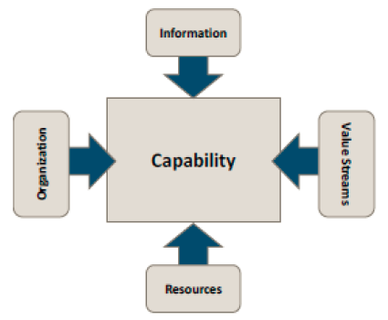
This is not to say that Resources, as the 4th key relationship in that Figure, is what capabilityImplementation amounts to being – this remains to be seen as the rest of the BIZBOK is somewhat vague on this particular relationship. In any event, a process (or even activity) or service would seem to bring together “materials, technologies, funding, and other assets” to bear in realizing a capability, as characterized in the explanatory paragraph for Figure 2.2.2 (see page 52). Sorting out what would be the concrete classes for actually implementing a capability would seem to be in the purview of the MMCT as it consults its own expertise and experience base in meta modeling, albeit in a way that is consistent with or otherwise correctly normative of material in Part 3.5 of the BIZBOK.
- The likely use of process (or even activity) and service as those concrete classes place the MM for the BAF of the BIZBOK in good company with respect to other Frameworks. This means that the concept of something that brings a capability into being is well grounded in most practitioners’ expectations of what a BA should include.
While capability in TOGAF is criminally under-defined, what TOGAF calls a Business Architecture revolves around process. The concept of capability is not in this section, but its closest analog is function, which is mapped to the core concept of process.
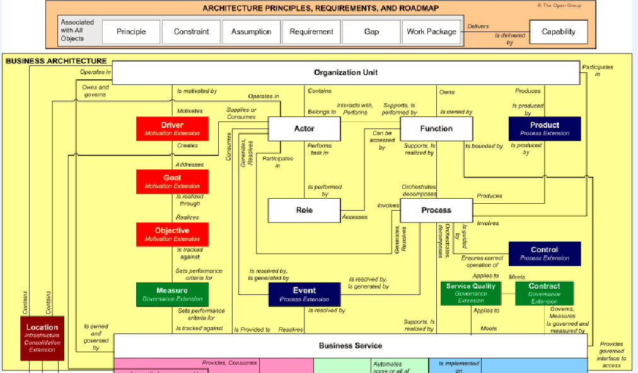
In DODAF, activity and capability are mapped to each other, with activity showing up in Operational View (OV) models such as OV-5b (IDEF/functional decomposition) and/or OV-6c (BPMN), while capability showing up in Capability View (CV) models such as CV-2 (capability taxonomy) or CV-6 (capability to operational activities maps).
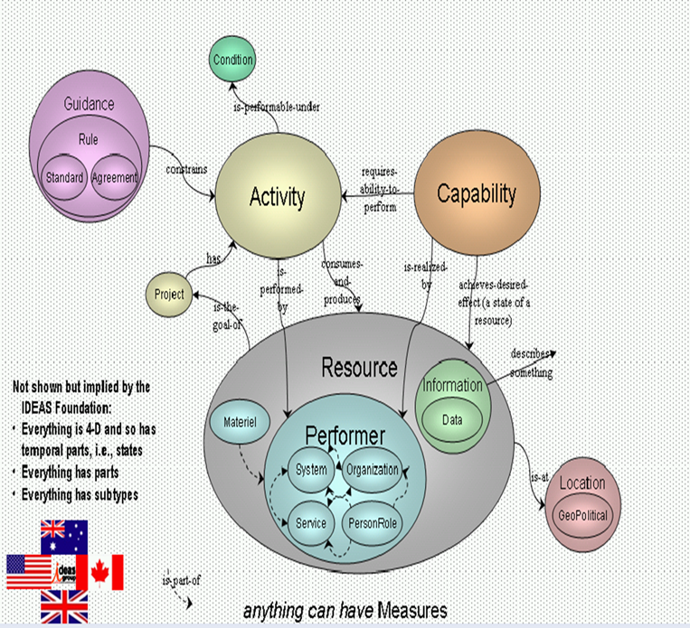
- The BA-BPMN Alignment material recently produced and presented in numerous BAG forums/conferences assumes such a relationship as is implicit in the abstract concept of capabilityImplementation – with a many-to-many mapping from process to capability – when mapping business process models to capability maps, as shown in the graphic below.
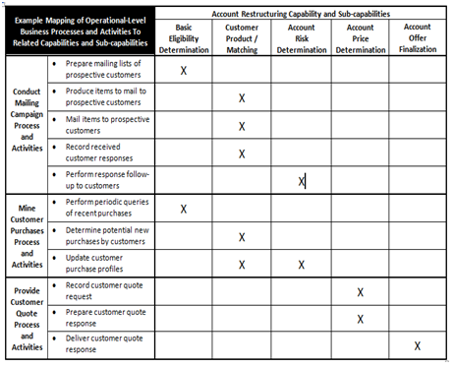
- When aligning with the Business Model constructs, including strategy as a concept, the concept of activity (with process as a container of activity) is a linchpin concept for describing how businesses realize goals and strategies, but the understanding of activity in this sense is more of a “what” (as is expected in the Business Model) than a “how” (as would make sense in the Operational Model). A recent example of creating BA artifacts around the Business Model Canvass showed how using “Capabilities” from a BA as “Key Activities” in the Canvass resolved mapping issues and made the resulting artifact useful as both an analytical tool and as a presentation device to senior management.
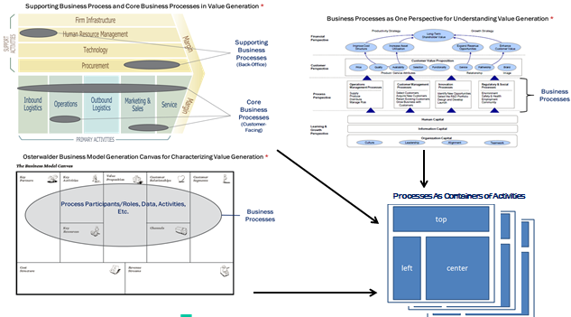
- Finally, as presented by Jim, the impact of capabilityImplementation on courseOfAction is consistent with how process affects courseOfAction in the OMG’s Business Motivation Model (BMM). It is also in line with other thinking amongst BA meta modelers that the thing implementing a capability can either enable or constrain a courseOfAction, which makes the linkage clearer and more actionable than it would otherwise be in the BMM. Consequently, capabilitlyImplementaton – as a supertype of process – makes this association clear, and enhances its meaning while preserving alignment with the modeling standard.
Second, the arguments against using “Capability Instance” – either in the MM or in the BIZBOK as the intended term for what “Capability Implementation” is to mean.
- There are typically three principal issues raised when discussing the meta modeling of capability and what an “Instance” of a capability would be. The first is how to version control current as-is architectural artifacts vs. target to-be architectural artifacts so as to be able to distinguish “Instances” of a capability across the temporal or planning horizon of the business itself. The second is about what to call the thing that actually implements a capability as an “Instance” of the capability as realized within the business. The third is whether or not to subptype capability as a class or to leave such refinement to be captured as a class attribute. This part of the memo addresses the first two of these.
Regarding the first issue, there is no clear-cut and generally understood approach outside of versioning entirely different sets of the BA itself (i.e., as-is, to-be, and interims). As show below, DODAF provides a possible approach in its Capability View (CV) model for such representations, the CV-3 (capability phasing), that maps a “Phase” to a capability that allows it to be associated with a variety of other views and other artifacts. In this approach, the capability has to be decomposed to a point where a “Phase” can be assigned, as opposed to capturing partial phasing of a higher level capability.
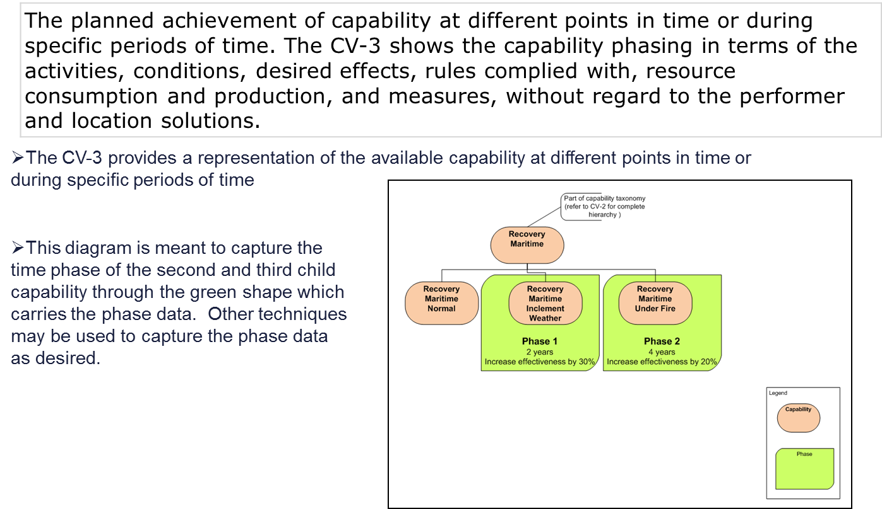
The MMCT acknowledges the need to address this issue by providing guidance and structure for business architects to apply the meta model in their own organization as capability is identified and versioned. Perhaps a phase concept is necessary to achieve this end, but the MMCT needs to work this out further in its meta modeling effort.
Regarding the second issue, the argument in the first thread of this memo makes the case that the generic label for such a thing should be capabilityImplementation, and that the MMCT should have the freedom to further refine this concept as an extension of the BAF for the BIZBOK, or to call out the hooks that related disciplines or methodologies can leverage for integrating other artifacts with BA artifacts created per the BIZBOK. Furthermore, it seems to the MMCT that the terminology for the thing that actually implements a capability should be independent of the package of concepts that include capability in the BAF. However, the concept of capabilityInstance will inevitably make the implementing concept subordinate to capability, which is not, in the judgement of the MMCT, the intention generally desired or as implicitly expressed in the BIZBOK.
- The use of the term “Instance” in capabilityInstance is highly problematic on at least two levels. In meta modeling that embraces the OMG’s approach called out in its material on the Meta Object Facility (MOF), which the BAG is presumably intending to follow given its intention to make the BIZBOK the basis for a future OMG modeling standard, “Instance” is practically a reserved word since it is the concept that links MOF levels to each other, and is the concept that is mapped to a class as a classifier in MOF Level 2.
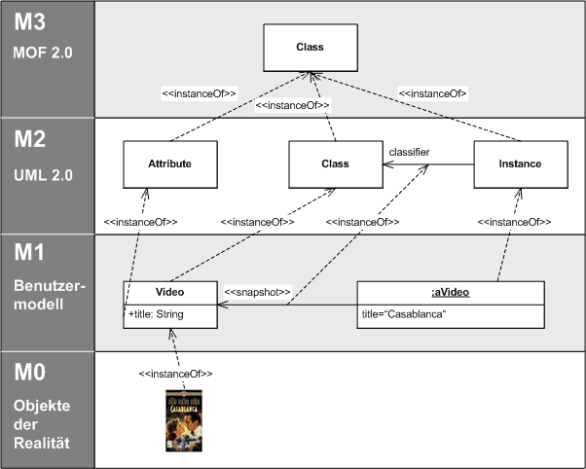
The first usage is decidedly NOT what is intended here, since the MMCT is attempting to create a MOF Level 2 meta model as the basis for the BIZBOK’s BAF. In this case, “Instance” would apply to the BA (as a MOF Level 1 model) created per a BAF (as the governing MOF Level 2 modeling language). For example, capability is the concept defined in the BAF as a MOF Level 2 class, and Claim Processing is defined as the associated concept in the BA as a MOF Level 1 class. (This would leave a MOF Level 0 “Instance” as the data captured/generated about a specific realization of a capability.)
The second usage is also decidedly NOT what is intended here because the implication that capabilityInstance is an “Instance” of capability means that it inherits all of the class attributes as an instantiation class of an abstract class. Such a result is counterintuitive relative to the idea that a capability is an abstract and technology-agnostic concept while the thing that implements a capability is a concrete and material thing.
- In ontological/semantic modeling circles, the term “Instance” is similar to the term “Individual” since it is understood as the actual instance of a class (e.g., as shown in the example below where the class “City” has an individual “London” that relates to other individuals of other classes – John as a “Person” and FlightDL210 as a “Flight”). This relationship is essentially similar to that between a class in the MOF Level 1 to the associated instance in the MOF Level 0. While advanced forms of semantic modeling allow for an intermingling (see punning in semantic modeling), there is no need for such complication in the development of the BAF for the BIZBOK. This especially important to consider if the creation of an OWL version of the BAF is desired.
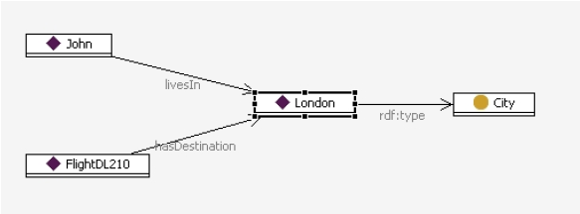
- Finally, it is the opinion of the MMCT that practitioners and modeling tool vendors generally will NOT recognize nor understand the term “Capability Instance” correctly, if at all, making the term a divisive concept that will create unnecessary confusions between BA communities. While the term “Capability Implementation” is not all that clear, it is positioned as a placeholder until further work is done, and has the benefit of carrying its meaning correctly in its label. The same cannot be said for the term “Capability Instance” given the problematic meaning of the term “Instance” as used.
These problems obtain even if the term “Capability Instance” is limited to just the BIZBOK, letting the MM call it whatever it will. This is because the term and its correct understanding will be critical in the creation of key BA artifacts, including heat maps that assess the quality of capability, and in communicating models across BA efforts.
Finally, the MMCT needs clarification on how to surface such issues in the future.
- This is not the first time such a problem has occurred, and it will not be the last. The MMCT needs to know its latitude in exploring the implication of a meta model for the BAF of the BIZBOK that defines concepts (classes), characteristics (class attributes), and linkages (structural relationships and cardinalities between concepts). It is understood that the charge of the MMCT is to create a MM that supports the BIZBOK, but as the MM is pushed forward to greater formalism, it is inevitable that some semantic and conceptual inconsistencies will emerge that may or may not be addressable through meta modeling, with the “may not” cases requiring changes to the BIZBOK.
- The MMCT accepts this challenge and the direction to keep any changes to the BIZBOK content to a minimum, but needs to be able to be clear with the EB when matters of meta modeling approach and clarity need to take precedence in editorial decisions. The MMCT’s concern with the EB’s recent decision is that it is not well grounded in meta modeling theory or practice, and compromises the BIZBOK’s utility.
- The MMCT would like to further define its relationship in this regard so that future exchanges are more productive, and respectfully asks for a future roundtable discussion with the EB and the MMCT to work out a more formal procedure for submitting any changes. The goal is to ensure consistency and transparency in this critical undertaking.
The MMCT respectfully submits this memorandum to the EB for its review. It would be greatly appreciated if the subject of the first two sections, the use of the term “Capability Instance,” could be addressed as soon as possible so as to not further impact the work of the MMCT to craft the MM for the BAF of the BIZBOK. Thank you for your consideration in this matter.

